Opening ceremony with Bernard Maillet (General Secretary of Eurpean Umion Medical Specialist)

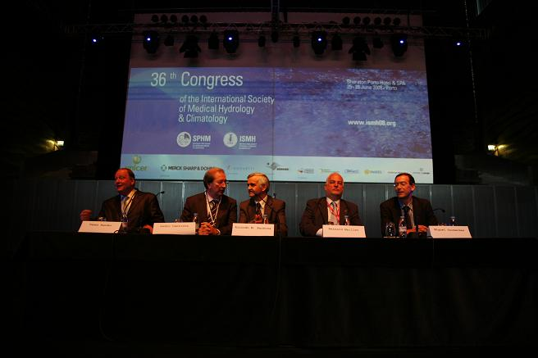
Tamas Bender(first vice President of ISMH ,Zeki Karagulle President of ISMH,Christoph Gutenbrunner vice President of ISMH ,Alice Sipos office leader of ISMH,Pedro Cantista vice President of ISPRM,Christian Roques General secretory of ISMH, Pal Geher treasurer of ISMH

